
Company
Logotype

Cone Beam Computed Tomography- Report



Porur Dental X-rays & CBCT

Patient Name : Mrs. Padmaveni | Date of Report : 08.07.2024
Age/ Gender : 41 years/ Female | Region of Interest : CBCT Maxilla
Referring doctor: Dr. Balamurali Sai | Indication : To rule out Periapical lesion ?
Clinical Notes: Nil
PATIENT INFORMATION

CBCT- Maxilla provided
CBCT – IMAGE DETAILS

RADIOGRAPHIC INTERPRETATION

- Root stumps 18; Dental caries and partial loss of crown: 27; Missing tooth: 28.
- In relation to the periapical aspect of 25, 26, 27 widening of periodontal ligament space and presence of diffuse areas of hypodensity between 26 and 27 involving the alveolar bone is evident.
- The hypodensity in relation to the periapical aspect of 27 appears to cause discontinuity of the floor of the left maxillary sinus.
- The floor of the left maxillary sinus is present with mucosal thickening, which appears to extend to the medial wall and lateral wall also.

RADIOGRAPHIC IMPRESSION

- Endo- Perio Lesion with periapical pathology: 27;
- Chronic periodontitis and periapical pathology in relation to 26.
- Left maxillary sinusitis.
- Root stumps 18;

Kindly correlate with clinical findings


IMAGES FOR REFERENCE

RECONSTRUCTED PANORAMIC VIEW
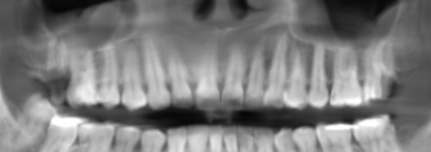

3-DIMENSIONAL VIEW

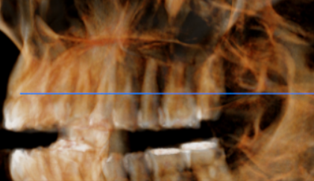

CROSS SECTIONAL VIEW
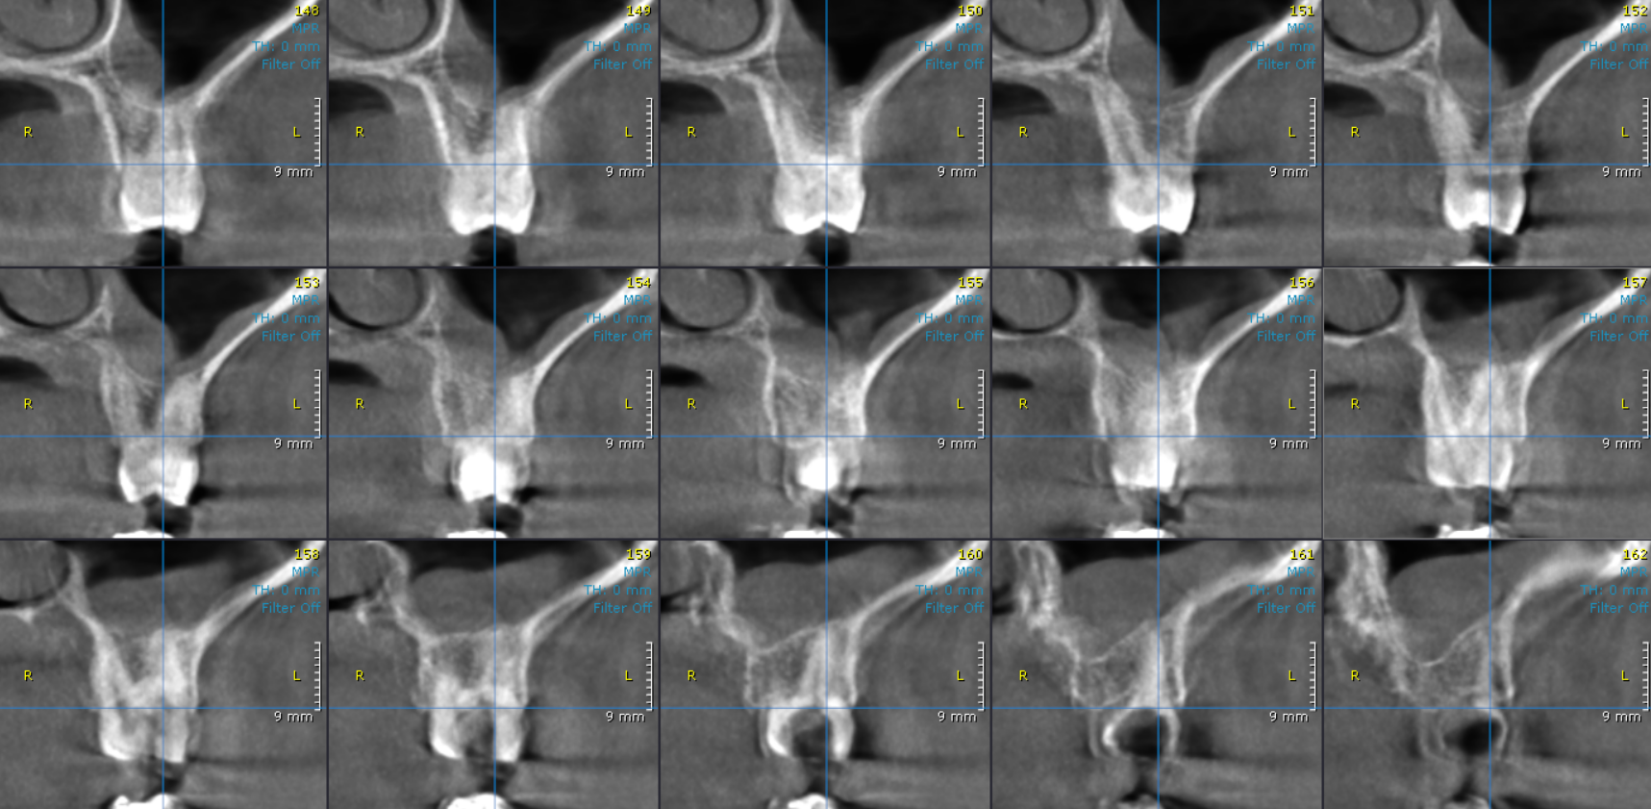
Presence of mucosal thickening in relation to the left maxillary sinus floor
Discontinuity of Floor of Maxillary sinus in relation to 27

**** End of report ****

